Democracy and Nazism: Germany, 1918–1933

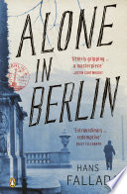
Read: ‘Alone in Berlin’ written by Hans Fallada
Berlin, 1940. The city is paralysed by fear. But one man refuses to be scared. Otto, an ordinary German living in a shabby apartment block, tries to stay out of trouble under Nazi rule. But when he discovers his only son has been killed fighting at the front he's shocked into an extraordinary act of resistance, and starts to drop anonymous postcards attacking Hitler across the city. If caught, he will be executed. Soon this silent campaign comes to the attention of ambitious Gestapo inspector Escherich, and a murderous game of cat-and-mouse begins. Whoever loses, pays with their life. 'First published in Germany in 1947 and evoking the horror of life in Germany in the Second World War.

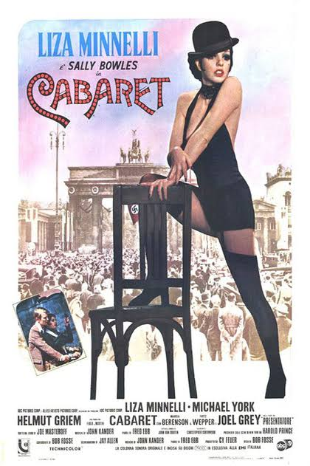
Watch: ‘Cabaret’ directed by Bob Fosse
1972 - Musical/Drama - 124 minutes
Sally is a cabaret dancer at the Kit Kat Klub and falls in love with two men who are regulars at the club. Their lives get entwined with the Nazi Party that is slowly growing in power. Great music/songs and Liza Minelli and Joel Gray are fabulous!

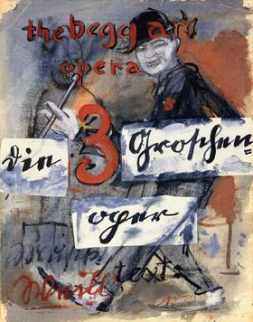
Listen: The Threepenny Opera (Die Dreigroschenoper) written by Bertolt Brecht and Kurt Weill
A "play with music" by Bertolt Brecht, adapted from a translation by Elisabeth Hauptmann of John Gay's 18th-century English ballad opera, The Beggar's Opera, and four ballads by François Villon, with music by Kurt Weill. Although there is debate as to how much, if any, Hauptmann might have contributed to the text, Brecht is usually listed as sole author. The work offers a socialist critique of the capitalist world. It opened on 31 August 1928 at Berlin's Theater am Schiffbauerdamm. Perhaps the most famous song from the ‘opera’ is ‘The Ballad of Mack the Knife’ which has become a standard for many more modern performers.

Visit (well a virtual one!):
Explore the Tate Modern & Tate Liverpool collections of Weimar Art. Start with Otto Dix (https://www.tate.org.uk/art/lists/five-things-know-otto-dix), ‘wander’ along to see George Grosz (https://www.tate.org.uk/art/artists/george-grosz-1223) then ‘visit’ August Sander https://www.tate.org.uk/art/artists/august-sander-5319/lists/five-things-know-august-sander and finally ‘take in’ the ‘Portraying a Nation: Germany 1919-1933 exhibition https://www.tate.org.uk/whats-on/tate-liverpool/exhibition/portraying-nation-germany-1919-1933

Stuart Britain and the Crisis of Monarchy, 1603–1702.

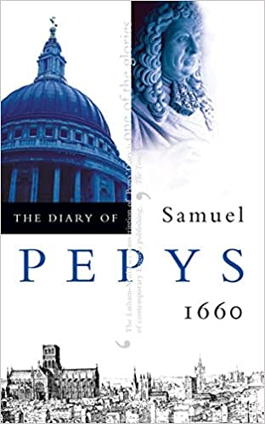
Read: The Diary of Samuel Pepys
Probably the most famous diary in the English language. Begun in January 1660 and finishing in May 1669, it offers a richly detailed account of some of the most turbulent events of the nation’s history, including the coronation of King Charles II, the Great Plague and the Great Fire of London. Pepys was an extremely observant commentator and his diary is an important historical document as it offers historians access to the thoughts, fears and preoccupations of people in the ‘Century of Revolution’. A good read also! The transcript of the diary is also available online: https://www.pepysdiary.com/diary/1660/01/

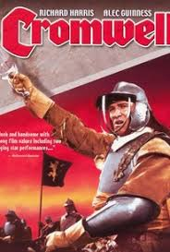
Watch: ‘Cromwell’ directed by Ken Hughes
1970 - Historical drama - 139 minutes
Oliver Cromwell can no longer tolerate King Charles' policies, and the self-interest of the ruling class, and leads a civil war to install Parliament as the ultimate ruler of England. A good summary of one of the key figures from the course. Some great acting too. Does exaggerate Cromwell’s role in the outbreak of the Civil War though so be careful.

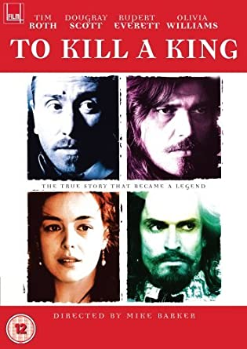
2003 - Historical drama - 94 minutes
As the English Civil War ends during the mid 17th century, Oliver Cromwell (Tim Roth) begins seizing power along with his leader, Gen. Thomas Fairfax (Dougray Scott). The dethroned British king, Charles I (Rupert Everett), is held captive while Cromwell, Fairfax and their allies decide his fate. Although Charles attempts to win Fairfax's wife, Lady Anne (Olivia Williams), over to his side, and the ruler still has many loyalists, Cromwell is determined to see the king go to trial.

Listen: Freeborn John - The Story Of John Lilburne - The Leader Of The Levellers written by Rev Hammer

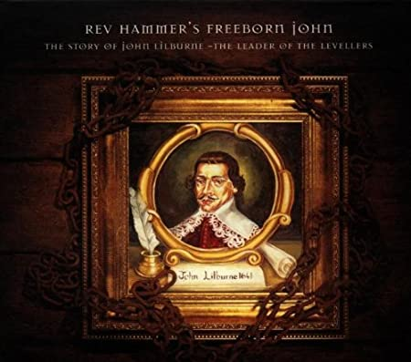
Released in 1997 this concept album tells the tale of John Lilburne, England's first radical, an unsung hero of the Civil War and a religious agitator who fought for freedoms of speech, of the press and of conscience. Understandably, this was an all-consuming project that took Rev Hammer a couple of years to complete. To tell the tale, he enlisted the likes of Maddy Prior, Eddi Reader, Rory McLeod and his long-time friends, New Model Army and The Levellers . (Warning - This may not be for everyone, if not have a look at John Lilburne’s life story- he lived an eventful one!)

Visit (well a virtual one!):
This is great and will familiarise you with the key characters we will study. https://www.npg.org.uk/collections/explore/by-period/stuarts-and-civil-war

This is a good exhibition on Charles II and the Restoration period. https://www.rct.uk/collection/themes/exhibitions/charles-ii-art-power/the-queens-gallery-palace-of-holyroodhouse

Enjoy!

